Comparative Analysis of Neutron Moderator Materials:
Neutronic Performance, Radiation Effects, and Engineering Constraints
Dhruv Sharma

Abstract
Neutron moderators are essential to both fission-based reactor systems and spallation neutron sources because they control how effectively fast neutrons can be slowed into thermal or cold energy ranges. Although the physical role of moderation is conceptually simple, the material challenge that underlies it is highly complex. An effective moderator must bring together efficient energy transfer, favorable scattering behavior, acceptable neutron absorption, sufficient radiation tolerance, manageable thermal properties, and realistic engineering requirements. This paper examines several leading moderator materials liquid hydrogen, solid methane, ice, methane hydrate, mesitylene, light water, and heavy water with particular focus on cold-neutron applications and to the experimental findings reported for the JESSICA facility at Forschungszentrum Julich. The analysis considers how hydrogen density, molecular structure, temperature-dependent scattering mechanisms, radiolysis, thermal conductivity, and containment constraints shape overall suitability.
The central finding from the comparative evidence is that no material is universally optimal. Solid methane provides the strongest low-energy cold-neutron performance, but severe radiation-related difficulties reduce its operational attractiveness. Ice shows a distinct and useful spectral profile and performs better than methane in part of the intermediate energy region, though it does not match methane at the lowest energies. Methane hydrate, initially attractive as a hybrid concept, does not provide the expected superposition of methane-like and ice-like benefits. Mesitylene appears as a particularly important compromise because it offers high hydrogen content together with improved radiation behavior relative to methane, even though its neutron spectrum is less intense. Liquid hydrogen continues to be one of the most powerful practical moderators for high-performance systems, but it requires demanding cryogenic engineering and careful management of radiolysis and ortho–para conversion. Light water and heavy water remain essential reference cases because they illustrate the continuing importance of practicality, absorption, neutron economy, and long-established reactor design logic.
A second major theme of this paper is radiation damage. Moderator performance cannot be evaluated solely from neutron-spectrum plots. Under irradiation, molecular dissociation, radical formation, hydrogen generation, stored chemical energy, and abrupt release events can turn a high-performing moderator into a difficult engineering liability. The paper therefore brings together neutronic performance with radiation effects and with broader system design considerations. Its conclusion is that moderator selection should not be understood as a search for the single “best” substance in absolute terms, but as a comparative design decision driven by the application’s priorities whether those priorities are maximum cold-neutron output, long-term stability, lower neutron absorption, operational simplicity, or safe and reproducible performance under sustained irradiation.

1. Introduction
Neutron moderation is a central process in applied nuclear physics. In both reactors and neutron-source facilities, neutron behavior depends strongly on energy. Fast neutrons are produced in energetic nuclear environments, but many useful nuclear processes become more probable after those neutrons have been slowed. Thermal neutrons are essential in many reactor designs because lower energies increase the probability of fission in fissile isotopes and improve controllability. Cold neutrons, which are even lower in energy, are especially valuable in neutron-scattering science because they possess longer wavelengths and are better suited to the investigation of structure and dynamics in materials. For this reason, the moderator occupies a uniquely important position in system design: it is both a physical tool for controlling neutron energy and an engineering component that must remain reliable under demanding conditions.
At first glance, selecting a moderator seems straightforward. It might appear that the ideal material is simply the one that slows neutrons the fastest. In practice, moderation depends on several interconnected quantities. The moderator nucleus must be sufficiently light to allow large energy transfer in collisions. The material should contain a sufficiently high density of those nuclei so that neutrons undergo many interactions within a compact volume. It must also avoid excessive neutron absorption during this process. For cold-neutron applications, the material’s molecular and lattice dynamics become particularly important because low-energy excitations influence the resulting energy spectrum. At the same time, a practical moderator must survive radiation damage, conduct away deposited heat, resist cracking or instability, and remain safe to store and operate. These requirements often push material selection in competing directions.
Hydrogen-rich materials repeatedly appear among the most attractive moderators because hydrogen nuclei are nearly equal in mass to neutrons, maximizing energy transfer per collision. This basic principle explains why substances such as liquid hydrogen, solid methane, water, ice, methane hydrate, and hydrogen-rich organic compounds have received sustained scientific attention. However, hydrogen-rich moderation also introduces difficulties. Many high-performing cold moderators must operate at very low temperatures, often around 20 K. Some are chemically reactive or flammable. Some suffer from poor thermal conductivity. Under irradiation, several hydrogen-bearing materials develop radicals, gas products, carbonaceous deposits, and stored chemical energy, which can eventually be released suddenly. A material that appears strongest from a purely neutronic standpoint may therefore become less attractive once full operating conditions are considered.
This paper examines the leading materials discussed in the source research and presents them within a single academic study. The discussion begins with the physical basis of neutron moderation, because the comparative results are clearest when viewed against the underlying collision physics. It then considers the JESSICA experiment, which offers direct comparative evidence for solid methane, ice, methane hydrate, mesitylene, and liquid hydrogen at cryogenic temperature. A broader material-by-material comparison then follows, integrating hydrogen density, scattering behavior, radiation stability, and mechanical or engineering limitations. The paper next develops the topic of radiation effects in depth, especially radiolysis and stored-energy release in methane, before concluding with an overall evaluation of what the evidence implies for moderator design. Throughout, the aim is to present a standalone research paper that explains not only which materials perform well, but also why they do so and under which limits that performance remains meaningful.

2. Physical Basis of Neutron Moderation
The basic physics of moderation begins with elastic scattering. When a neutron collides with a nucleus, some of the neutron’s kinetic energy is transferred to that nucleus. The efficiency of this transfer depends heavily on the relative masses of the two particles. A very heavy nucleus cannot take up a large fraction of the neutron’s energy in a single collision, so many interactions are required to produce substantial slowing. A light nucleus, in contrast, can accept a much larger fraction of the energy. Hydrogen is therefore almost ideal because its nucleus, the proton, has a mass close to that of the neutron. In a hydrogen-rich medium, a neutron can lose a substantial share of its kinetic energy per collision, allowing moderation to occur rapidly and within a compact volume.
Moderator effectiveness does not depend only on the fractional energy loss in a single collision. The number of collisions a neutron experiences is also important. This is why hydrogen density repeatedly appears in moderator comparisons. A material with many hydrogen atoms per unit volume or per unit mass provides frequent opportunities for scattering, increasing the probability that a fast neutron will be slowed before it escapes. This is one reason why substances such as methane and water are so influential in moderation science. Their chemical structure allows large populations of hydrogen nuclei to be packed into a small volume, though the detailed scattering behavior differs from one compound to another.
Scattering alone is not enough to define a good moderator. A material may slow neutrons effectively but still be unattractive if it absorbs too many of them. Absorption removes neutrons from the useful neutron population and can reduce neutron economy in reactor settings or lower beam intensity in source applications. This point is particularly important when comparing ordinary hydrogen and deuterium. Hydrogen is better at transferring energy per collision because of its lower mass, but deuterium absorbs neutrons far less strongly. Heavy water therefore is attractive where neutron economy is a high priority, even though more collisions and larger volumes are required to obtain equivalent slowing. The trade-off is therefore fundamental: strong moderation and low absorption do not always occur together in the same material.
Another concept central to moderator selection is the mean free path. In hydrogen-bearing media, neutrons encounter scattering centers frequently, and therefore undergo rapid moderation over relatively short distances. In deuterium-bearing media, the neutron mean free path is larger. As a result, a deuterium moderator may require a larger physical region to achieve similar energy reduction. The source research highlights this distinction explicitly, noting that the mean free path in deuterium can exceed 100 mm, whereas in hydrogen it is under 20 mm. These differences shape not only neutronic performance but also system geometry, shielding demands, and mechanical design.
For thermal and especially cold moderators, molecular structure adds a further layer of complexity. Hydrogen in water, methane, and aromatic organic compounds does not behave in the same way. Rotational modes, vibrational modes, intermolecular disorder, and lattice excitations each influence the probability distribution of energy exchanges between neutrons and the moderator. This is why two materials with similarly high hydrogen content can produce clearly different neutron spectra. The structured environment of water ice, the molecular dynamics of solid methane, and the phase behavior of mesitylene lead to distinct cold-neutron outputs. For this reason, the phrase “hydrogen-rich” is helpful but incomplete; what matters is not only how much hydrogen a material contains, but how that hydrogen participates in the material’s low-temperature dynamics.
The average logarithmic energy decrement is commonly used to characterize how much energy a neutron loses on average in each collision. Hydrogen-rich materials generally perform well by this measure because of the light target mass. However, even a large decrement does not ensure suitability. If the material becomes unstable under irradiation, or if it must be maintained in an extremely demanding cryogenic state, or if its low thermal conductivity permits destructive local heating, then its theoretical appeal can be substantially reduced. In practical terms, the moderator problem is a multivariable optimization problem. The best candidate is not the material that excels in a single category, but the one that offers the most favorable balance across the categories that matter for a specific application.
This balance becomes even more delicate in modern cold-neutron science. Researchers are not only seeking efficient slowing; they are also trying to shape the resulting energy spectrum. A moderator may be selected because it maximizes very-low-energy neutrons, because it provides a broader useful band, because it is stable at higher power, or because it supports safer, more reproducible operation over long irradiation periods. The remainder of the paper should therefore be read with a key principle in mind: differences among moderator materials are not only differences in strength, but also differences in spectral character, in radiation behavior, and in the engineering cost of using that behavior effectively.

3. Experimental Evidence from the JESSICA Facility
A major body of evidence used in this analysis comes from the JESSICA facility, the Julich Experimental Spallation Target Set-up In COSY Area, installed in the synchrotron COSY at Forschungszentrum Julich in Germany. JESSICA was designed to reproduce experiments on a target–moderator–reflector system relevant to the European Spallation Source. The facility is significant because it allows candidate moderator materials to be compared under conditions directly relevant to high-value neutron-source design. Rather than relying only on abstract theoretical expectations, researchers can examine how different materials actually shape the outgoing neutron spectrum at cryogenic temperature.
One of the clearest observations from from the JESSICA work is that, at 20 K, solid methane exhibits a maximum neutron flux at approximately 4 meV, whereas ice reaches its strongest intensity around 8 meV. This difference is important. It indicates that methane and ice do not merely represent stronger and weaker versions of the same moderator. Instead, they emphasize different parts of the low-energy spectrum. Methane dominates at the very lowest energies, while ice becomes relatively more effective in a somewhat higher interval. The comparison is highly relevant for source design because the ideal spectrum depends on experimental use. Some instruments or scientific applications may prefer the deepest cold-neutron enhancement; others may benefit from a somewhat broader or shifted energy distribution.
The contrast between methane and ice also encouraged a search for hybrid materials that might combine the advantages of both. Methane hydrate appeared to be a promising candidate because it consists of methane molecules enclosed in a water-based lattice. Conceptually, it seemed reasonable to hope that this architecture might permit the low-energy strength of methane and the intermediate-energy contribution of ice to coexist in a single moderator. If such a superposition had been achieved, methane hydrate would have represented a highly attractive design solution: one material, one cryogenic system, and a broadened useful spectrum.
The JESSICA data, however, do not support this expectation. The spectral measurements show that methane hydrate does not show a simple superposition of the methane and ice spectra. Instead, its measured shape resembles that of solid methane, but with significantly lower intensity, described in the research as reduced by a factor of about three. This result is scientifically significant because it demonstrates that hybrid chemical composition does not automatically produce hybrid neutronic behavior. The collective vibrational and structural dynamics of the hydrate govern the scattering process, and those dynamics do not merely preserve the separate advantages of methane and ice side by side. The hydrate behaves as its own material, not as a simple additive combination.
The first figure included in this paper illustrates that outcome. The methane curve reaches the highest low-energy intensity, the ice curve rises more strongly in the higher portion of the cold-to-epithermal region, and the methane-hydrate points remain below methane while broadly following a similar shape. This is one of the key lessons from the experiment: intuition based on chemical composition can be misleading unless it is confirmed by actual spectral measurements.
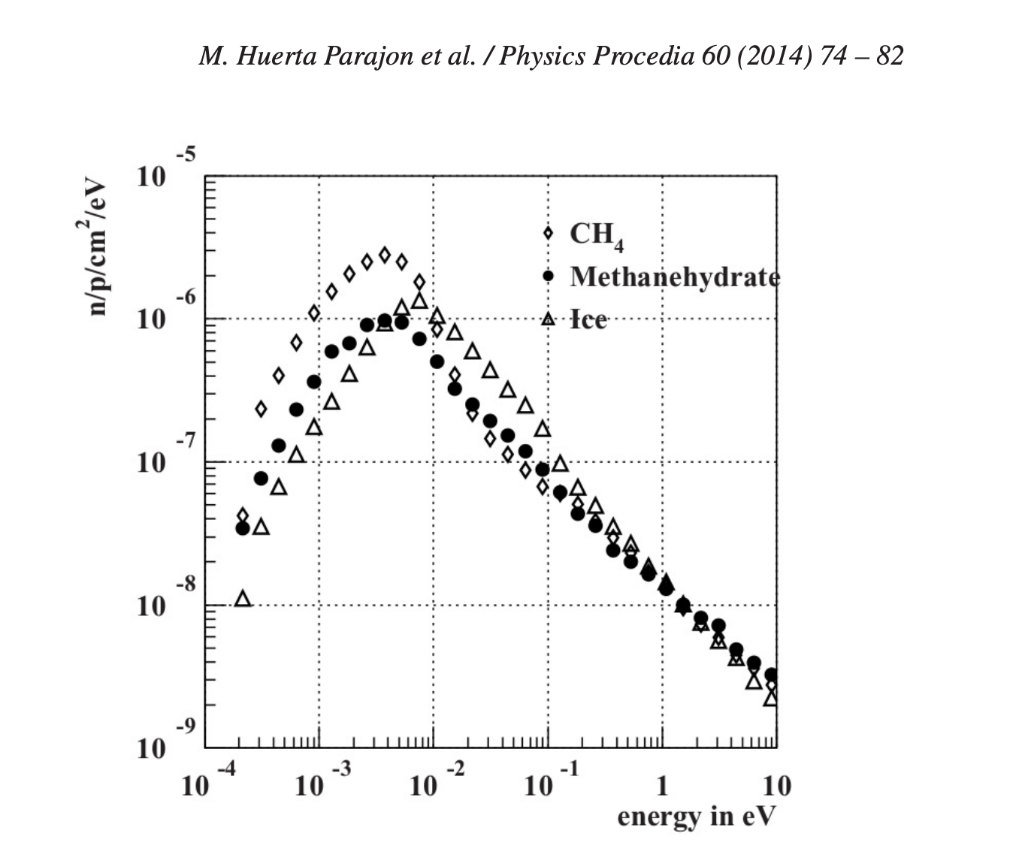
Figure 1. Measured energy spectra for ice, methane, and methane hydrate at 20 K, illustrating methane’s stronger very-low-energy flux and the reduced intensity of methane hydrate.
JESSICA also investigated mesitylene, an aromatic compound with three methyl groups attached symmetrically to a benzene ring. The source research emphasizes its high hydrogen density and the weakly hampered rotation of the methyl groups. Solid mesitylene can exist in several phases, and Phase II, the disordered phase, is identified as especially relevant to cryogenic moderation. Disorder is not simply a structural curiosity here; it influences the low-energy excitations available for neutron scattering. Mesitylene’s behavior therefore reflects not only its hydrogen content but also its phase-dependent molecular freedom and structural organization.
In Figure 2, mesitylene is compared with solid methane, ice, and liquid hydrogen at 20 K. Methane again shows the strongest low-energy output, but mesitylene remains competitive across part of the range and displays a spectrum that is both scientifically useful and operationally interesting. The significance of mesitylene becomes clearer when combined with the later radiation discussion, where it is described as less severely affected by irradiation than methane. This combination of good, though not maximal, neutronic performance and improved radiation stability makes mesitylene one of the most compelling candidate materials in the overall comparison.
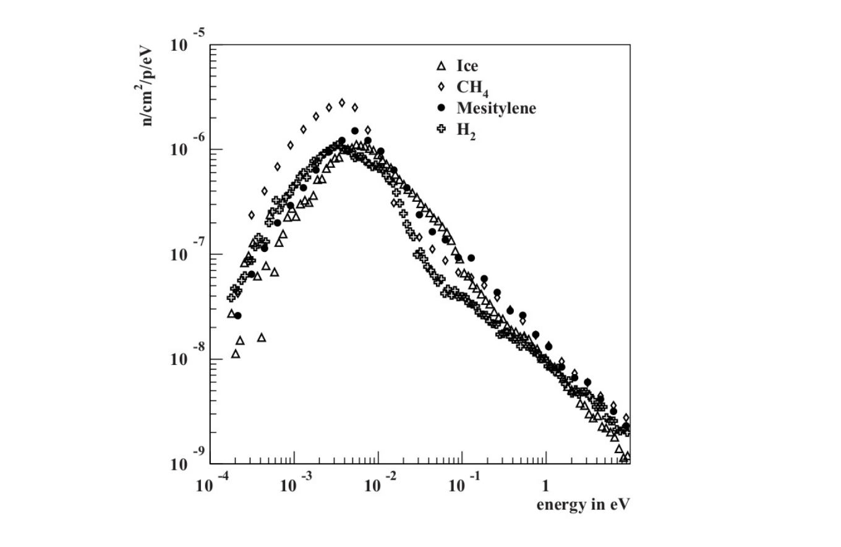
Figure 2. Measured energy spectra for ice, solid methane, mesitylene, and liquid hydrogen at 20 K, showing different spectral strengths and the comparative position of mesitylene.
Liquid hydrogen is included in the same comparative framework as a benchmark of high-performance cryogenic moderation. It is recognized for strong cold-neutron production and excellent moderation efficiency, but its system-level demands are severe. The JESSICA comparison helps place it alongside the more chemically complex molecular moderators. The result is not that one material simply replaces another, but that the spectrum of design choices becomes more visible. Methane offers exceptional flux. Hydrogen offers elite moderation with cryogenic complexity. Ice offers a different spectrum. Mesitylene offers compromise. Methane hydrate offers a cautionary example. In this sense, the JESSICA experiment does more than compare data points: it shows the multidimensional nature of the moderator problem.

4. Comparative Evaluation of Moderator Materials
The JESSICA figures provide direct evidence, but a full material comparison requires a broader analytical frame. For this reason, the table below summarizes the major candidate moderators discussed in the research in terms of hydrogen density, thermal scattering behavior, radiation stability, and engineering limitations. The tabulated comparison is not intended to serve as a simplistic ranking. Instead, it serves as a structured map of trade-offs. Each material addresses certain problems while introducing others. The sections that follow expand the table in prose so that the significance of each category is made fully explicit.
Moderator | Hydrogen Density | Thermal Scattering Properties | Radiation Stability | Mechanical / Engineering Limitations
Liquid Hydrogen (H2) | Very high hydrogen atom density per unit mass; low molecular mass maximizes energy transfer. | Excellent for cold neutrons; high average logarithmic energy decrement; strong inelastic scattering at cryogenic temperatures. | Moderate radiation resistance; radiolysis possible; hydrogen gas buildup risk. | Requires cryogenic temperatures (~20 K); complex containment; explosion risk.
Solid Methane (CH4) | Extremely high hydrogen density (4 H atoms per molecule). | Very strong cold neutron production due to rotational and vibrational modes enhancing scattering. | Poor radiation stability; gas-bubble formation and cracking under irradiation. | Maintained at ~20 K; brittle; sensitive to thermal cycling.
Ice (H2O solid) | High hydrogen density; slightly lower than liquid hydrogen per unit volume. | Effective thermal scattering; bound hydrogen improves cold neutron yield. | More stable than methane; radiation-induced defects possible. | Requires sub-zero conditions; structural stress from irradiation.
Methane Hydrate (CH4·nH2O) | Very high hydrogen density from both methane and water components. | Strong cold neutron moderation; combined hydrogen sources enhance scattering. | Improved stability compared to pure methane; gradual degradation under irradiation. | Requires high-pressure, low-temperature stability; complex phase behavior.
Mesitylene (C9H12) | High hydrogen content (12 H atoms per molecule); lower density than methane. | Good cold neutron scattering; aromatic structure influences energy spectrum. | Better radiation resistance than methane; organic breakdown possible. | Flammable; chemical stability concerns; cryogenic handling required.
Light Water (H2O) | High hydrogen density; widely used industrially. | Very effective moderator; high scattering cross-section; higher absorption than D2O. | Excellent radiation tolerance in power reactors. | Boiling limits temperature; corrosion and pressure control required.
Heavy Water (D2O) | Similar atomic density to light water but heavier nucleus (deuterium). | Lower absorption cross-section; requires more collisions to thermalize neutrons. | Highly radiation stable; used in long-life reactor systems. | Expensive; leakage losses costly; complex handling systems.
Table 1. Comparative summary of leading moderator materials, emphasizing the trade-offs among hydrogen density, scattering behavior, radiation tolerance, and engineering demands.

4.1 Liquid Hydrogen
Liquid hydrogen is among the most powerful moderator materials available for cold-neutron systems. Because of the very low mass of the hydrogen nucleus, the energy transfer per collision is high. In addition, hydrogen’s scattering characteristics at cryogenic temperature are highly favorable for producing intense cold neutrons. These features explain why liquid hydrogen has become central in many high-performance neutron-source designs, especially those associated with high-power spallation facilities. In a purely neutronic sense, liquid hydrogen often appears close to ideal.
However, the engineering burden attached to liquid hydrogen is substantial. It must be maintained near 20 K, requiring a highly reliable cryogenic system with carefully controlled heat loads, insulation, and containment. Hydrogen’s flammability and explosion risk increase the importance of leak prevention and monitoring. In addition, irradiation can produce radiolysis products, and gas-management issues can complicate the internal state of the moderator system. A very high-performing substance is therefore acceptable only if the facility is capable of supporting its temperature, safety, and containment demands.
A particularly important complication is ortho–para hydrogen conversion. At room temperature, liquid hydrogen exists in a normal composition containing roughly 75% ortho hydrogen and 25% para hydrogen. At low temperature, this ratio is unstable; the ortho form gradually converts to the para form until the hydrogen becomes predominantly para hydrogen, approaching 99% near 20 K. Each conversion releases energy, about 1.47 meV per event according to the research considered here. This affects both thermal management and scattering behavior, because below about 100 meV the neutron scattering cross-section depends on the ortho–para ratio. For a liquid-hydrogen moderator, the molecular spin-state composition is therefore not incidental; it is a genuine design variable.

4.2 Solid Methane
Solid methane is often treated as the benchmark material for intense cold-neutron production. Its extremely high hydrogen density and favorable rotational and vibrational scattering modes give it excellent performance at low neutron energies. The JESSICA data confirm this by showing that methane has the highest neutron flux in the lowest part of the measured spectrum, with a maximum near 4 meV and superiority over ice below approximately 8 meV. When assessed solely by immediate neutronic output, methane is exceptionally attractive.
The difficulty arises from its behavior under realistic irradiation. Solid methane has poor thermal conductivity, so deposited energy is not removed effectively. At cryogenic temperature, this leaves the material vulnerable to local heating, structural stress, and instability. The research also notes gas-bubble formation and cracking under irradiation. Methane must be maintained near 20 K and is brittle and sensitive to thermal cycling. As a result, a facility using methane must manage not only a strong neutron-producing material but also one that is mechanically fragile and thermally unforgiving.
Radiation chemistry extends the problem further. Under irradiation, methane molecules can dissociate to form radicals such as methyl and hydrogen. Recombination processes can then produce hydrogen gas and reactive carbon fragments that later contribute to wax-like alkane deposits, often represented as (−CH2−)n. These deposits can impede flow and reduce moderator efficiency. More importantly, part of the radiolysis chemistry is associated with the accumulation of stored energy, which may later be released abruptly in a so-called burp event. Such releases are dangerous operationally because they are not merely thermal fluctuations; they are chemical-energy release phenomena tied to radiation-induced damage. Methane therefore illustrates a recurring theme in moderator science: the material with the most attractive spectrum may be the one that creates the hardest engineering problem.

4.3 Ice
Ice provides a useful point of comparison because it contains bound hydrogen in a structurally ordered medium and produces a different neutron spectrum from methane. The JESSICA results indicate that ice reaches its highest intensity near 8 meV and becomes superior to methane over part of the interval from approximately 8 meV to 1 eV. This makes it valuable when the desired neutron output is not concentrated entirely at the very lowest energies. The role of bound hydrogen in the ice lattice contributes to thermal scattering behavior that differs from molecular methane, even though both materials are hydrogen-rich.
Compared with methane, ice appears somewhat more stable, though it is not free of practical problems. The research points to radiation-induced defects and to structural stress under irradiation. Ice also requires low-temperature operation, and the mismatch between radiation deposition, thermal gradients, and structural integrity can still limit performance. However, it avoids some of methane’s most severe radiolysis-related difficulties and does not dominate the discussion of sudden stored-energy release in the same way. This makes it a more moderate but potentially more manageable option.
The comparison between ice and methane is not merely academic. It reflects a fundamental design choice between maximum low-energy enhancement and a broader, differently weighted spectrum with somewhat less severe material penalties. The fact that methane hydrate was explored at all reflects how attractive it seemed to combine the strengths of these two materials. Ice therefore matters not only as an individual moderator but also as one half of an important conceptual pairing in cold-moderator development.

4.4 Methane Hydrate
Methane hydrate is chemically interesting because it places methane molecules inside a water-based lattice. That structure gives it a very high combined hydrogen content and initially suggested that it might inherit favorable features from both methane and ice. In broad comparative terms, it seems to offer high hydrogen density and a potentially rich scattering environment. It is therefore understandable that it was proposed as a candidate material capable of broadening the useful neutron-energy range.
However, the measurements show that methane hydrate does not fulfill that early expectation. Instead of producing a superposed methane-plus-ice spectrum, it behaves more like a weaker version of methane. Its intensity is significantly below methane’s, while its shape remains similar enough that it does not provide a fundamentally new advantage. This is a scientifically revealing result. It indicates that combined chemistry does not ensure combined neutronic benefits. The hydrate lattice produces its own collective scattering behavior, and that collective behavior does not preserve the separate best features of the parent materials.
Methane hydrate also retains practical disadvantages. It still requires low temperatures and stable phase conditions, and the research notes refer to complex high-pressure, low-temperature behavior. It does not avoid radiolysis concerns and does not solve the stored-energy problem decisively. In effect, methane hydrate becomes a valuable lesson in negative design logic: a conceptually elegant solution can fail because the actual dynamics of the material do not align with the intuitive design goal.

4.5 Mesitylene
Mesitylene, or 1,3,5-trimethylbenzene, stands out because it offers a distinctly different path through the moderator problem. It is hydrogen-rich, with twelve hydrogen atoms per molecule, and its methyl groups possess rotational freedom that contributes to low-energy scattering in a useful way. The source research emphasizes that Phase II of solid mesitylene is disordered and especially interesting from the perspective of cryogenic moderation. Disorder in this context is beneficial because it supports favorable excitations and scattering pathways.
In terms of neutron output, mesitylene does not surpass methane. The JESSICA data place it below methane in peak low-energy intensity. Nevertheless, mesitylene remains scientifically important because its spectrum is still useful and because its practical behavior appears better. The research explicitly describes mesitylene as less affected by radiation than methane. It does not suffer the same degree of severe radiolysis-product buildup or spontaneous stored-energy burst release. This relative stability gives it a very different kind of value: not the maximum possible initial performance, but the prospect of better sustained operation.
Mesitylene still has limits. It is flammable, requires cryogenic handling, and remains an organic molecular material whose chemistry must be respected. However, the overall comparison strongly suggests that it deserves attention as a compromise candidate. A designer who is willing to accept somewhat lower cold-neutron intensity may obtain a material whose operational behavior is safer and more predictable. That is not a minor concession; in many real facilities, it may be the decisive one.

4.6 Light Water
Light water is the classic reactor moderator and remains indispensable as a benchmark of practical engineering success. It combines high hydrogen density, strong scattering, abundant availability, and an extensive body of operating experience. In power-reactor settings, it is often the most practical moderator because its engineering challenges, although real, are familiar and manageable. It supports strong moderation and integrates naturally into systems where boiling, pressure, corrosion, and coolant–moderator coupling are already central design features.
Its main limitation is its relatively higher neutron absorption compared with heavy water. In applications where neutron economy is critical, that absorption penalty can matter significantly. Nevertheless, light water remains perhaps the strongest example of a material that balances neutronic adequacy with engineering maturity. In any broad comparison, it reminds us that the “best” moderator in practice may be the one supported by decades of design knowledge rather than the one with the most impressive specialist spectrum.

4.7 Heavy Water
Heavy water replaces ordinary hydrogen with deuterium and thereby changes the moderator balance in a very revealing way. Deuterium absorbs far fewer neutrons than protium, so heavy water preserves neutron population more effectively. This is why heavy water has been central to reactor systems where neutron economy matters deeply. It is highly stable under radiation and supports long-term operation in carefully designed systems.
The cost of these advantages is reduced moderation strength per collision and the need for larger moderator volumes because of the longer mean free path. Heavy water is also expensive, and leakage is economically significant. Complex recovery and handling systems are often justified by the value of the material. Heavy water therefore illustrates a complementary logic to that of methane or hydrogen: not maximal cold-neutron intensity, but conservative neutron preservation and strong reactor economics under a different design objective.

5. Radiation Effects, Radiolysis, and Stored-Energy Release
Radiation effects are among the most important and often underestimated aspects of moderator behavior. A moderator is exposed to a hostile flux environment in which energetic particles deposit heat, break chemical bonds, generate radicals, alter phase stability, and progressively change the material’s microscopic state. Because neutron moderation depends on microscopic structure and dynamics, radiation damage is not merely a durability problem; it can change the very neutronic properties for which the moderator was selected. The practical value of a moderator therefore depends on how it behaves not just before irradiation, but during and after exposure to an operating radiation field.
The source research identifies radiolysis as a key process. In hydrogen-bearing moderators, irradiation can dissociate molecules and create radicals. These radicals may recombine into new stable products, into gaseous species, or into polymer-like or carbonaceous deposits. At the same time, some of the chemical pathways store energy in the irradiated material. If this stored energy is not released gradually and harmlessly, it may accumulate and later be discharged abruptly. The research emphasizes that this possibility is critically important because it can damage the moderator container and compromise operational safety.
Solid methane provides the clearest example. The radiolysis pathway described in the source material begins with bond breaking in methane, producing methyl and hydrogen radicals. Recombination then leads to hydrogen gas formation and to CH2-type fragments that eventually contribute to wax-like alkane deposits. The reaction H + H → H2 is associated with the release of substantial energy, which helps explain how stored energy can build up. Once sufficient dose accumulates, that energy may be released in a sudden burp event. Such an event is not a minor disturbance. It can produce thermal shock, pressure changes, and structural consequences severe enough to limit the usefulness of methane despite its excellent cold-neutron performance.
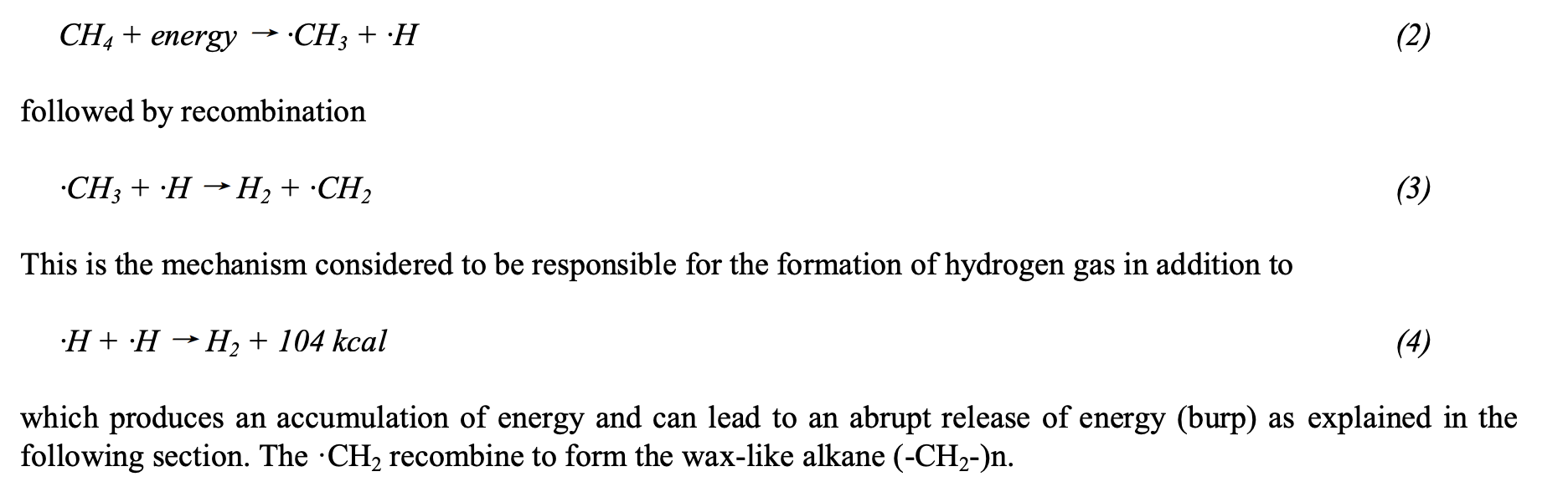
Figure 3. Simplified methane-radiolysis pathway showing radical formation, hydrogen production, and the origin of stored-energy release associated with burp events.
Poor thermal conductivity further worsens the methane problem. Because the material cannot redistribute deposited heat efficiently, local temperature gradients may develop. These gradients can contribute to cracking, bubble formation, or microstructural disruption. In low-power neutron sources, such risks may remain manageable. Under higher-power conditions, they become much more serious. This is why the research notes distinguish between the use of liquid hydrogen in high-power spallation sources and solid methane in lower-power neutron sources: the thermal and radiolytic penalties of methane become difficult to tolerate as power density rises.
Liquid hydrogen also introduces radiation-related challenges, although of a different kind. Radiolysis remains relevant, and gas management is a persistent concern. In addition, ortho–para conversion changes the moderator’s thermal behavior and scattering properties over time. Because the conversion releases energy, it must be controlled in a cryogenic environment where even modest heat loads are significant. Liquid hydrogen thus illustrates that even the cleanest-looking cryogenic moderator can be controlled by subtle internal processes that reshape both performance and operational complexity.
Ice and methane hydrate occupy intermediate cases. Neither dominates the discussion of catastrophic stored-energy release as strongly as methane, but neither is immune to radiation-induced change. Ice can develop defects under irradiation and still requires careful thermal and structural management. Methane hydrate is still limited by the fact that it does not significantly outperform methane while retaining nontrivial complexity and unresolved radiation concerns. If a material fails to deliver a clear spectral advantage, even moderate radiation issues may become sufficient reason to reject it.
Mesitylene is particularly important in the radiation discussion because it represents the possibility of improved stability within the class of hydrogen-rich molecular moderators. The research characterizes mesitylene as less severely affected by radiation, with fewer radiolysis products and without the methane-like spontaneous burst releases of stored energy. This does not mean that mesitylene is immune to all damage. As an organic material, it still poses chemical and flammability concerns. But its relative improvement supports a crucial design lesson: it is possible to seek hydrogen-rich moderators that do not reproduce methane’s most severe operational liabilities.
Overall, the radiation evidence changes the meaning of “performance.” A moderator that begins with the strongest neutron spectrum may not be the best performer over time if radiation progressively alters its structure, generates problematic byproducts, or forces operators to use conservative limits that sacrifice its theoretical advantage. Conversely, a material with slightly lower flux may become more valuable if it provides stable, repeatable operation and lower risk. Any serious research paper on moderator choice must therefore integrate neutron-output measurements with irradiation behavior rather than treating them as separate topics.

6. Design Implications and Overall Discussion
When the material comparisons and radiation effects are considered together, a broader design logic becomes clear. Moderator choice depends fundamentally on the application. A high-intensity cold-neutron source built for specialized scattering science may accept a difficult cryogenic system or a relatively delicate material if the gain in low-energy neutron flux is scientifically decisive. A power-reactor environment, by contrast, may prioritize neutron economy, coolant integration, long operating life, and engineering familiarity. This is why materials that look very different in the laboratory can each occupy rational positions in real-world systems.
Solid methane exemplifies the difference between laboratory excellence and engineering challenge. If the design objective is maximum low-energy neutron intensity and the system can tolerate the operational burden, methane remains one of the strongest options available. However, if reliability, stability, and predictable maintenance intervals are valued more highly, then methane’s radiolysis products, cracking risk, and stored-energy behavior become major drawbacks. Mesitylene, though weaker spectrally, becomes attractive precisely because it changes the trade-off curve.
Liquid hydrogen occupies a different strategic position. It combines very strong moderation with strong institutional familiarity in advanced cryogenic neutron systems, yet it demands disciplined control of temperature, containment, and hydrogen state. It is not an easy option, but it is a mature high-performance choice when a facility is built around it. Heavy water, by contrast, represents a reactor-centered logic in which low absorption and neutron economy justify higher cost and larger moderator volume. Light water demonstrates that the most widely used moderator may be the one whose entire package, performance, cost, familiarity, integration, and safety practice, fits the system best, even if its neutronic metrics are not unique.
A further design lesson concerns hybrid-material thinking. Methane hydrate was attractive because it seemed to promise a synthetic combination of methane’s and ice’s strengths. The measurements show that nature does not always reward such intuitive combinations. Moderator material development must therefore remain strongly empirical. Molecular architecture, phase behavior, and collective excitations govern scattering in ways that are not obvious from chemical formula alone. New moderators should be evaluated not only through compositional reasoning but also through spectral measurement and irradiation testing.
The evidence also points toward a broader research direction. The most valuable future materials are likely to be those that preserve the hydrogen-rich scattering advantages required for strong cold moderation while simultaneously improving thermal conductivity, radiation tolerance, and predictable behavior under repeated dose. This goal may be pursued through new molecular solids, engineered composites, or tailored phase-control strategies, but whatever path is taken, the key is integration: neutronics, radiation chemistry, and engineering should be treated as one design problem rather than as separate stages of evaluation.
In this sense, moderator science offers a broader lesson in nuclear engineering. Materials cannot be judged through isolated properties alone. Their value emerges from how those properties interact under realistic operating conditions. The moderator that appears optimal in a narrow spectral sense may prove inferior at the scale of the full system, while a material that seems less impressive at first may become the most rational choice when life-cycle performance is considered. The present comparison of hydrogen, methane, ice, hydrate, mesitylene, light water, and heavy water supports exactly that conclusion.

7. Conclusion
The comparative study developed in this paper leads to a clear conclusion: there is no universally optimal neutron moderator. The most suitable material depends on the balance of physical performance and engineering practicality demanded by the application. Hydrogen-rich materials remain central because their low nuclear mass gives them unmatched moderation efficiency. Within that group, solid methane provides the strongest cold-neutron output at the lowest energies and therefore stands out in purely neutronic terms. Ice provides a useful alternative spectral profile, stronger than methane over part of the intermediate range even though it cannot match methane at the coldest energies. Methane hydrate, despite its conceptual appeal, demonstrates that hybrid composition does not automatically translate into hybrid neutronic advantage. Mesitylene shows that slightly lower intensity may be worth accepting when it comes with improved radiation behavior. Liquid hydrogen combines elite moderation with major cryogenic and safety demands. Light water and heavy water remind us that the moderator problem extends well beyond specialist cold-neutron optimization and into the broader domain of system integration, neutron economy, and long-term operating practicality.
The strongest unifying theme is the importance of trade-offs. Spectral performance matters, but so do radiolysis, stored-energy release, mean free path, neutron absorption, thermal conductivity, flammability, pressure and temperature requirements, and engineering maturity. A material’s usefulness cannot be captured by a single graph or a single scalar measure. Moderator selection is most properly understood as a comparative design decision that weighs how a material behaves before irradiation, under irradiation, and over sustained operation. By integrating the JESSICA data, the material comparison, and the radiation-effects evidence, this paper shows that the true challenge of moderator design is not discovering one perfect substance, but managing the tension between competing strengths and weaknesses in a way that suits the scientific or reactor objective at hand.
Future work in this field should continue to focus on materials that retain the strong moderation efficiency of hydrogen-rich systems while reducing the operational penalties that accompany many current candidates. This will likely require deeper coordination among neutron physics, cryogenic engineering, radiation chemistry, and materials science. The best next-generation moderator may not be the one that simply exceeds methane or hydrogen in one narrow category, but the one that achieves a more favorable overall balance. Until such a material is realized, the evidence reviewed here supports a nuanced view: methane remains the benchmark for maximum cold-neutron output, liquid hydrogen remains the premier high-performance practical moderator in advanced cryogenic systems, mesitylene remains one of the most interesting compromise candidates, and water-based moderators remain essential examples of how practicality and neutron economy shape real nuclear design.

References
Barnert-Wiemer, T. (2012). Research on hydrogen and deuterium cold moderators, including mean free path, ortho–para conversion, and proton density considerations.
Cantargi, F., and Granada, J.R. (2010). Research on mesitylene as a cryogenic moderator and the role of its disordered phase in neutron moderation.
Evans, L. (1995). Work discussing radiation-induced deposits and degradation pathways in solid methane moderators.
Nunighoff, K., et al. (2008). Experimental work on methane, ice, and methane hydrate spectra relevant to the JESSICA comparison.
Huerta Parajon, M., et al. (2014). Experimental discussion of candidate moderator materials and energy spectra in Physics Procedia.

